**activity_main.xml:**

<?xml version="1.0" encoding="utf-8"?>

<LinearLayout xmlns:android="http://schemas.android.com/apk/res/android"

android:orientation="vertical"

android:layout_width="match_parent"

android:layout_height="match_parent">

<TextView android:id="@+id/textView" android:layout_width="match_parent"

android:layout_height="wrap_content"

android:layout_margin="30dp"

android:gravity="center"

android:text="Text To Test"

android:textSize="25sp"

android:textStyle="bold" />

<Button

android:id="@+id/button"

android:layout_width="match_parent"

android:layout_height="wrap_content"

android:layout_margin="20dp"

android:gravity="center"

android:text="Change font size"

android:textSize="25sp" />

<Button

android:id="@+id/button1"

android:layout_width="match_parent"

android:layout_height="wrap_content"

android:layout_margin="20dp"

android:gravity="center"

android:text="Change color"

android:textSize="25sp" />

<TextView android:id="@+id/textView1"

android:layout_width="match_parent"

android:layout_height="wrap_content"

android:gravity="center"

android:text="Name: Vinod Kumar L"

android:textSize="25sp" />

<TextView

android:id="@+id/textView2"

android:layout_width="match_parent"

android:layout_height="wrap_content"

android:gravity="center"

android:text="RegNo: 950019104050"

android:textSize="25sp" />

</LinearLayout>

**MainActivity.java:**

package com.font.color;

import android.graphics.Color;

import android.os.Bundle;

import android.view.View;

import android.widget.Button;

import android.widget.TextView;

import androidx.appcompat.app.AppCompatActivity;

public class MainActivity extends AppCompatActivity

{

int ch=1;

float font=30;

@Override

protected void onCreate(Bundle savedInstanceState)

{

super.onCreate(savedInstanceState);

setContentView(R.layout.activity_main);

final TextView t= (TextView) findViewById(R.id.textView);

Button b1= (Button) findViewById(R.id.button);

b1.setOnClickListener(new View.OnClickListener() {

@Override

public void onClick(View v) {

t.setTextSize(font);

font = font + 5;

if (font == 50)

font = 30;

}

});

Button b2= (Button) findViewById(R.id.button1);

b2.setOnClickListener(new View.OnClickListener() {

@Override

public void onClick(View v) {

switch (ch) {

case 1:

t.setTextColor(Color.RED);

break;

case 2:

t.setTextColor(Color.GREEN);

break;

case 3:

t.setTextColor(Color.BLUE);

break;

case 4:

t.setTextColor(Color.CYAN);

break;

case 5:

t.setTextColor(Color.YELLOW);

break;

case 6:

t.setTextColor(Color.MAGENTA);

break;

}

ch++;

if (ch == 7)

ch = 1;

}

});

}

}

**Output:**

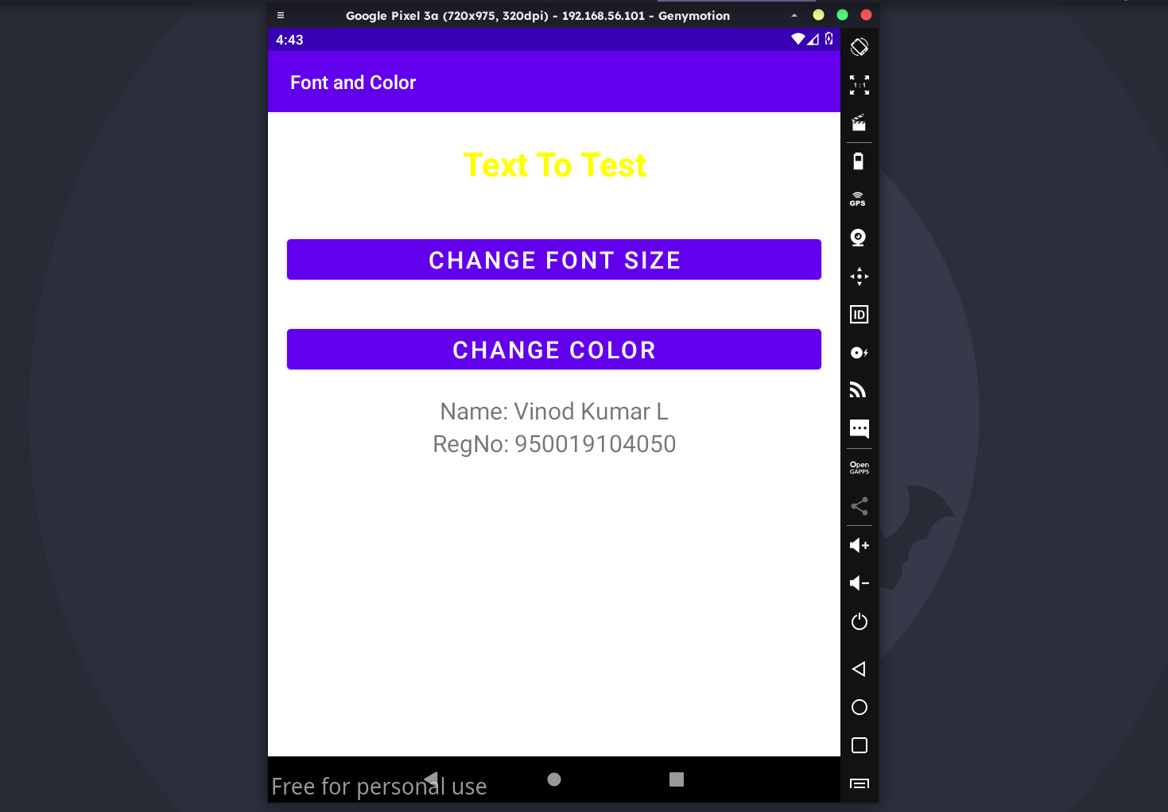

**activity_main.xml:**

<?xml version="1.0" encoding="utf-8"?>

<RelativeLayout xmlns:android="http://schemas.android.com/apk/res/android"

xmlns:tools="http://schemas.android.com/tools"

android:layout_width="match_parent"

android:layout_height="match_parent"

tools:context=".MainActivity">

<LinearLayout

android:layout_width="match_parent"

android:layout_height="100dp">

<TextView

android:id="@+id/textView"

android:layout_width="match_parent"

android:layout_height="wrap_content"

android:layout_margin="30dp"

android:text="Details Form"

android:textSize="25sp"

android:gravity="center"/>

</LinearLayout>

<GridLayout

android:id="@+id/gridLayout"

android:layout_width="match_parent"

android:layout_height="match_parent"

android:layout_marginTop="100dp"

android:layout_marginBottom="200dp"

android:columnCount="2"

android:rowCount="3">

<TextView

android:id="@+id/textView1"

android:layout_width="wrap_content"

android:layout_height="wrap_content"

android:layout_row="0"

android:layout_column="0"

android:layout_margin="10dp"

android:gravity="center"

android:text="Name"

android:textSize="20sp" />

<EditText

android:id="@+id/editText"

android:layout_width="wrap_content"

android:layout_height="wrap_content"

android:layout_row="0"

android:layout_column="1"

android:layout_margin="10dp"

android:ems="10" />

<TextView

android:id="@+id/textView2"

android:layout_width="wrap_content"

android:layout_height="wrap_content"

android:layout_row="1"

android:layout_column="0"

android:layout_margin="10dp"

android:gravity="center"

android:text="Reg.No"

android:textSize="20sp" />

<EditText

android:id="@+id/editText2"

android:layout_width="wrap_content"

android:layout_height="wrap_content"

android:layout_row="1"

android:layout_column="1"

android:layout_margin="10dp"

android:ems="10"

android:inputType="number" />

<TextView

android:id="@+id/textView3"

android:layout_width="wrap_content"

android:layout_height="wrap_content"

android:layout_row="2"

android:layout_column="0"

android:layout_margin="10dp"

android:gravity="center"

android:text="Dept"

android:textSize="20sp" />

<Spinner

android:id="@+id/spinner"

android:layout_width="wrap_content"

android:layout_height="wrap_content"

android:layout_row="2"

android:layout_column="1"

android:layout_margin="10dp"

android:spinnerMode="dropdown" />

</GridLayout>

<Button

android:id="@+id/button"

android:layout_width="wrap_content"

android:layout_height="wrap_content"

android:layout_alignParentBottom="true"

android:layout_centerInParent="true"

android:layout_marginBottom="150dp"

android:text="Submit"/>

<TextView android:id="@+id/textView11"

android:layout_width="match_parent"

android:layout_height="wrap_content"

android:gravity="center"

android:layout_marginTop="600dp"

android:text="Name: Vinod Kumar L"

android:textSize="25sp" />

<TextView

android:id="@+id/textView12"

android:layout_width="match_parent"

android:layout_height="wrap_content"

android:gravity="center"

android:text="RegNo: 950019104050"

android:layout_marginTop="650dp"

android:textSize="25sp" />

</RelativeLayout>

**activity_second.xml:**

<?xml version="1.0" encoding="utf-8"?>

<LinearLayout xmlns:android="http://schemas.android.com/apk/res/android"

xmlns:tools="http://schemas.android.com/tools"

android:layout_width="match_parent"

android:layout_height="match_parent"

tools:context="com.layoutmanager.listener.SecondActivity"

android:orientation="vertical"

android:gravity="center">

<TextView

android:id="@+id/textView1"

android:layout_width="wrap_content"

android:layout_height="wrap_content"

android:layout_margin="20dp"

android:text="New Text"

android:textSize="30sp"/>

<TextView

android:id="@+id/textView2"

android:layout_width="wrap_content"

android:layout_height="wrap_content"

android:layout_margin="20dp"

android:text="New Text"

android:textSize="30sp"/>

<TextView

android:id="@+id/textView3"

android:layout_width="wrap_content"

android:layout_height="wrap_content"

android:layout_margin="20dp"

android:text="New Text"

android:textSize="30sp"/>

</LinearLayout>

**MainActivity.java:**

package com.layoutmanager.listener;

import android.content.Intent;

import android.os.Bundle;

import android.view.View;

import android.widget.ArrayAdapter;

import android.widget.Button;

import android.widget.EditText;

import android.widget.Spinner;

import androidx.appcompat.app.AppCompatActivity;

public class MainActivity extends AppCompatActivity {

//Defining the Views

EditText e1,e2;

Button bt;

Spinner s;

//Data for populating in Spinner

String [] dept_array={"CSE","ECE","IT","Mech","Civil"};

String name,reg,dept;

@Override

protected void onCreate(Bundle savedInstanceState) {

super.onCreate(savedInstanceState);

setContentView(R.layout.activity_main);

//Referring the Views

e1= (EditText) findViewById(R.id.editText);

e2= (EditText) findViewById(R.id.editText2);

bt= (Button) findViewById(R.id.button);

s= (Spinner) findViewById(R.id.spinner);

//Creating Adapter for Spinner for adapting the data from array to Spinner

ArrayAdapter adapter= new

ArrayAdapter(MainActivity.this,android.R.layout.simple_spinner_item,dept_array);

s.setAdapter(adapter);

//Creating Listener for Button

bt.setOnClickListener(new View.OnClickListener() {

@Override

public void onClick(View v) {

//Getting the Values from Views(Edittext & Spinner)

name=e1.getText().toString();

reg=e2.getText().toString();

dept=s.getSelectedItem().toString();

//Intent For Navigating to Second Activity

Intent i = new Intent(MainActivity.this,SecondActivity.class);

//For Passing the Values to Second Activity

i.putExtra("name_key", name);

i.putExtra("reg_key",reg);

i.putExtra("dept_key", dept);

startActivity(i);

}

});

}}

**SecondActivity.java:**

package com.layoutmanager.listener;

import androidx.appcompat.app.AppCompatActivity;

import android.content.Intent;

import android.os.Bundle;

import android.widget.TextView;

public class SecondActivity extends AppCompatActivity {

TextView t1,t2,t3;

String name,reg,dept;

@Override

protected void onCreate(Bundle savedInstanceState) {

super.onCreate(savedInstanceState);

setContentView(R.layout.activity_second);

t1= (TextView) findViewById(R.id.textView1);

t2= (TextView) findViewById(R.id.textView2);

t3= (TextView) findViewById(R.id.textView3);

//Getting the Intent

Intent i = getIntent();

//Getting the Values from First Activity using the Intent received

name=i.getStringExtra("name_key");

reg=i.getStringExtra("reg_key");

dept=i.getStringExtra("dept_key");

//Setting the Values to Intent

t1.setText(name);

t2.setText(reg);

t3.setText(dept);

}

}

**Output:**

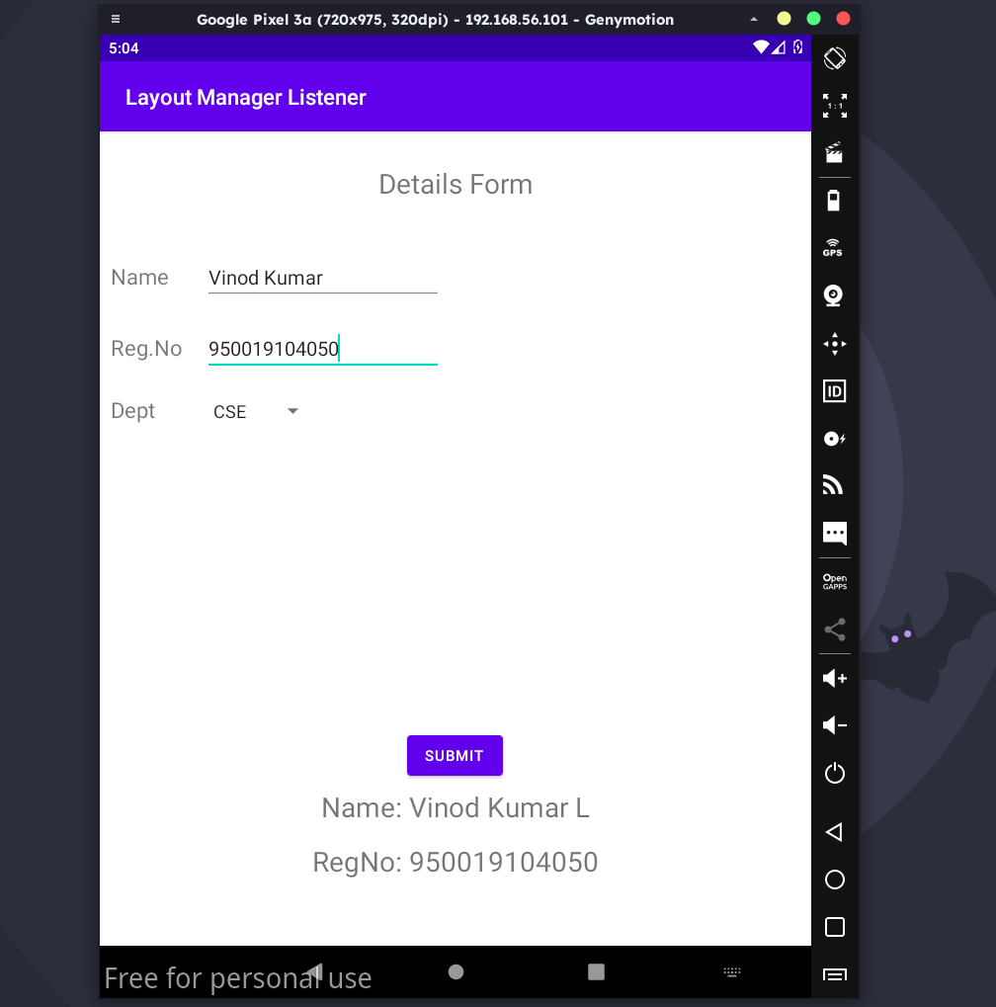

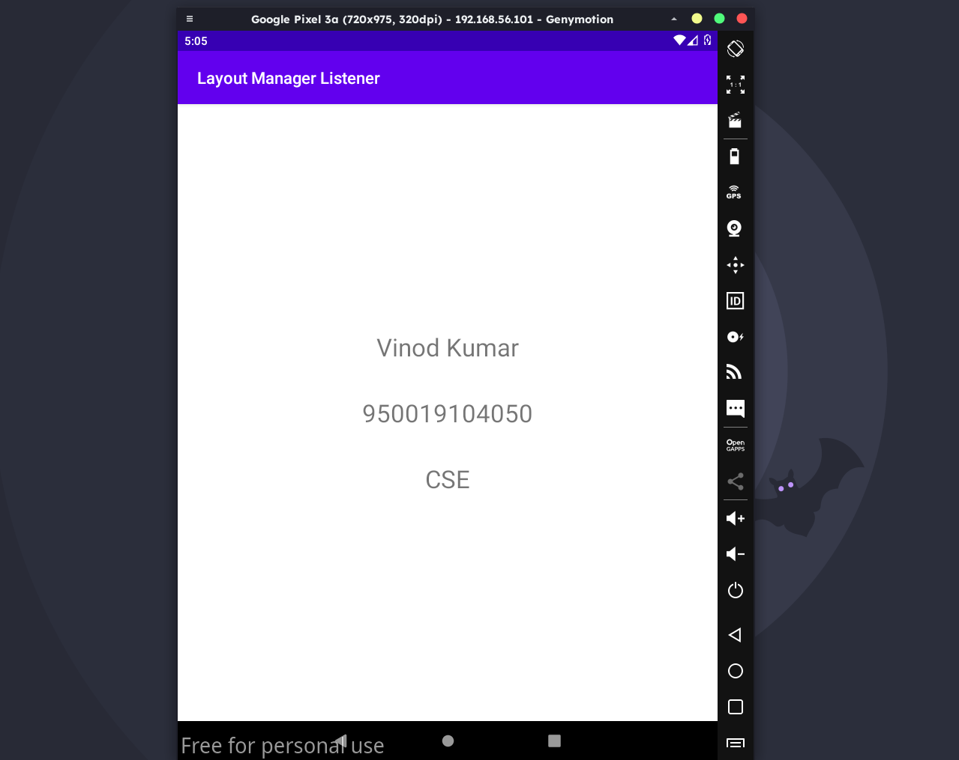

**activity_main.xml:**

<?xml version="1.0" encoding="utf-8"?>

<RelativeLayout xmlns:android="http://schemas.android.com/apk/res/android"

android:layout_width="match_parent"

android:layout_height="match_parent">

<ImageView

android:layout_width="match_parent"

android:layout_height="match_parent"

android:id="@+id/imageView" />

</RelativeLayout>

**MainActivity.java:**

package draw.basic.graphical.primitives;

import android.app.Activity;

import android.graphics.Bitmap;

import android.graphics.Canvas;

import android.graphics.Color;

import android.graphics.Paint;

import android.graphics.drawable.BitmapDrawable;

import android.os.Bundle;

import android.widget.ImageView;

public class MainActivity extends Activity {

@Override

public void onCreate(Bundle savedInstanceState) {

super.onCreate(savedInstanceState);

setContentView(R.layout.activity_main);

//Creating a Bitmap

Bitmap bg = Bitmap.createBitmap(720, 1280, Bitmap.Config.ARGB_8888);

//Setting the Bitmap as background for the ImageView

ImageView i = (ImageView) findViewById(R.id.imageView);

i.setBackgroundDrawable(new BitmapDrawable(bg));

//Creating the Canvas Object

Canvas canvas = new Canvas(bg);

//Creating the Paint Object and set its color & TextSize

Paint paint = new Paint();

paint.setColor(Color.BLUE);

paint.setTextSize(50);

//To draw a Rectangle

canvas.drawText("Rectangle", 420, 150, paint);

canvas.drawRect(400, 200, 650, 700, paint);

//To draw a Circle

canvas.drawText("Circle", 120, 150, paint);

canvas.drawCircle(200, 350, 150, paint);

//To draw a Square

canvas.drawText("Square", 120, 800, paint);

canvas.drawRect(50, 850, 350, 1150, paint);

//To draw a Line

canvas.drawText("Line", 480, 800, paint);

canvas.drawLine(520, 850, 520, 1150, paint);

}

}

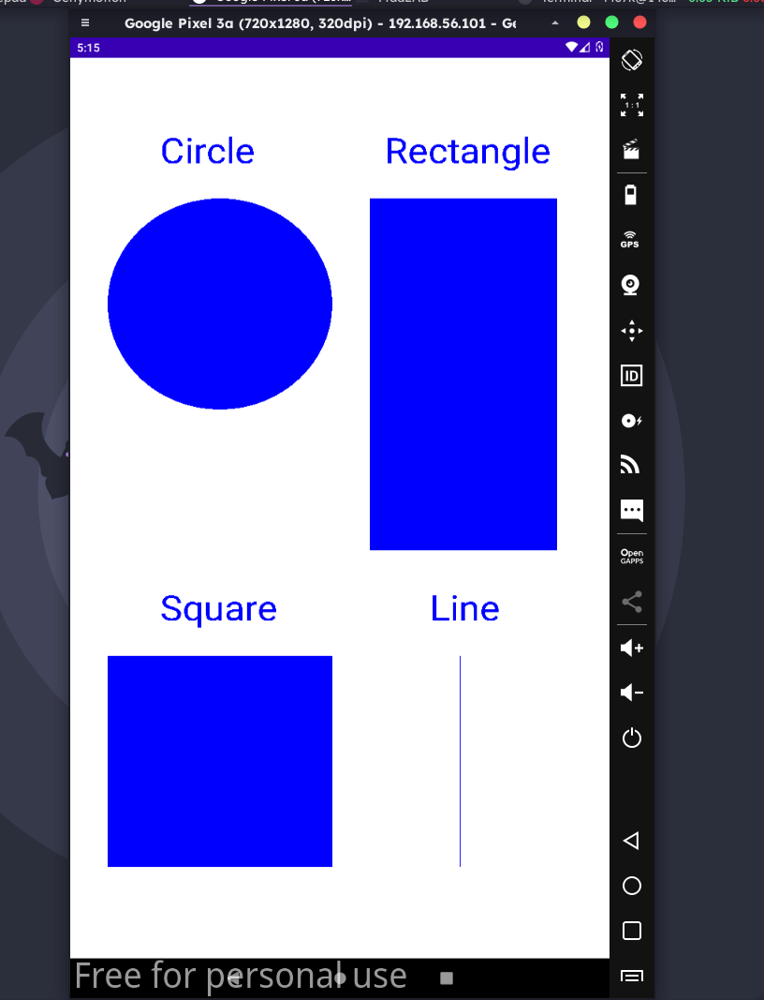

**activity_main.xml:**

<?xml version="1.0" encoding="utf-8"?>

<AbsoluteLayout xmlns:android="http://schemas.android.com/apk/res/android"

android:layout_width="match_parent"

android:layout_height="match_parent">

<TextView

android:layout_width="wrap_content"

android:layout_height="wrap_content"

android:layout_x="50dp"

android:layout_y="20dp"

android:text="Student Details"

android:textSize="30sp" />

<TextView

android:layout_width="wrap_content"

android:layout_height="wrap_content"

android:layout_x="20dp"

android:layout_y="110dp"

android:text="Enter Rollno:"

android:textSize="20sp" />

<EditText

android:id="@+id/Rollno"

android:layout_width="150dp"

android:layout_height="wrap_content"

android:layout_x="175dp"

android:layout_y="100dp"

android:inputType="number"

android:textSize="20sp" />

<TextView

android:layout_width="wrap_content"

android:layout_height="wrap_content"

android:layout_x="20dp"

android:layout_y="160dp"

android:text="Enter Name:"

android:textSize="20sp" />

<EditText

android:id="@+id/Name"

android:layout_width="150dp"

android:layout_height="wrap_content"

android:layout_x="175dp"

android:layout_y="150dp"

android:inputType="text"

android:textSize="20sp" />

<TextView

android:layout_width="wrap_content"

android:layout_height="wrap_content"

android:layout_x="20dp"

android:layout_y="210dp"

android:text="Enter Marks:"

android:textSize="20sp" />

<EditText

android:id="@+id/Marks"

android:layout_width="150dp"

android:layout_height="wrap_content"

android:layout_x="175dp"

android:layout_y="200dp"

android:inputType="number"

android:textSize="20sp" />

<Button

android:id="@+id/Insert"

android:layout_width="150dp"

android:layout_height="wrap_content"

android:layout_x="25dp"

android:layout_y="300dp"

android:text="Insert"

android:textSize="30dp" />

<Button

android:id="@+id/Delete"

android:layout_width="150dp"

android:layout_height="wrap_content"

android:layout_x="200dp"

android:layout_y="300dp"

android:text="Delete"

android:textSize="30dp" />

<Button

android:id="@+id/Update"

android:layout_width="150dp"

android:layout_height="wrap_content"

android:layout_x="25dp"

android:layout_y="400dp"

android:text="Update"

android:textSize="30dp" />

<Button

android:id="@+id/View"

android:layout_width="150dp"

android:layout_height="wrap_content"

android:layout_x="200dp"

android:layout_y="400dp"

android:text="View"

android:textSize="30dp" />

<Button

android:id="@+id/ViewAll"

android:layout_width="200dp"

android:layout_height="wrap_content"

android:layout_x="100dp"

android:layout_y="500dp"

android:text="View All"

android:textSize="30dp" />

</AbsoluteLayout>

**MainActivity.java:**

package make.use.of.db;

import android.app.Activity;

import android.app.AlertDialog.Builder;

import android.content.Context;

import android.database.Cursor;

import android.database.sqlite.SQLiteDatabase;

import android.os.Bundle;

import android.view.View;

import android.view.View.OnClickListener;

import android.widget.Button;

import android.widget.EditText;

public class MainActivity extends Activity implements OnClickListener

{

EditText Rollno,Name,Marks;

Button Insert,Delete,Update,View,ViewAll;

SQLiteDatabase db;

/** Called when the activity is first created. */

@Override

public void onCreate(Bundle savedInstanceState)

{

super.onCreate(savedInstanceState);

setContentView(R.layout.activity_main);

Rollno=(EditText)findViewById(R.id.Rollno);

Name=(EditText)findViewById(R.id.Name);

Marks=(EditText)findViewById(R.id.Marks);

Insert=(Button)findViewById(R.id.Insert);

Delete=(Button)findViewById(R.id.Delete);

Update=(Button)findViewById(R.id.Update);

View=(Button)findViewById(R.id.View);

ViewAll=(Button)findViewById(R.id.ViewAll);

Insert.setOnClickListener(this);

Delete.setOnClickListener(this);

Update.setOnClickListener(this);

View.setOnClickListener(this);

ViewAll.setOnClickListener(this);

// Creating database and table

db=openOrCreateDatabase("StudentDB", Context.MODE_PRIVATE, null);

db.execSQL("CREATE TABLE IF NOT EXISTS student(rollno VARCHAR,name VARCHAR,marks VARCHAR);");

}

public void onClick(View view)

{

// Inserting a record to the Student table

if(view==Insert)

{

// Checking for empty fields

if(Rollno.getText().toString().trim().length()==0||

Name.getText().toString().trim().length()==0||

Marks.getText().toString().trim().length()==0)

{

showMessage("Error", "Please enter all values");

return;

}

db.execSQL("INSERT INTO student VALUES('"+Rollno.getText()+"','"+Name.getText()+

"','"+Marks.getText()+"');");

showMessage("Success", "Record added");

clearText();

}

// Deleting a record from the Student table

if(view==Delete)

{

// Checking for empty roll number

if(Rollno.getText().toString().trim().length()==0)

{

showMessage("Error", "Please enter Rollno");

return;

}

Cursor c=db.rawQuery("SELECT * FROM student WHERE rollno='"+Rollno.getText()+"'", null);

if(c.moveToFirst())

{

db.execSQL("DELETE FROM student WHERE rollno='"+Rollno.getText()+"'");

showMessage("Success", "Record Deleted");

}

else

{

showMessage("Error", "Invalid Rollno");

}

clearText();

}

// Updating a record in the Student table

if(view==Update)

{

// Checking for empty roll number

if(Rollno.getText().toString().trim().length()==0)

{

showMessage("Error", "Please enter Rollno");

return;

}

Cursor c=db.rawQuery("SELECT * FROM student WHERE rollno='"+Rollno.getText()+"'", null);

if(c.moveToFirst()) {

db.execSQL("UPDATE student SET name='" + Name.getText() + "',marks='" +

Marks.getText() +

"' WHERE rollno='"+Rollno.getText()+"'");

showMessage("Success", "Record Modified");

}

else {

showMessage("Error", "Invalid Rollno");

}

clearText();

}

// Display a record from the Student table

if(view==View)

{

// Checking for empty roll number

if(Rollno.getText().toString().trim().length()==0)

{

showMessage("Error", "Please enter Rollno");

return;

}

Cursor c=db.rawQuery("SELECT * FROM student WHERE rollno='"+Rollno.getText()+"'", null);

if(c.moveToFirst())

{

Name.setText(c.getString(1));

Marks.setText(c.getString(2));

}

else

{

showMessage("Error", "Invalid Rollno");

clearText();

}

}

// Displaying all the records

if(view==ViewAll)

{

Cursor c=db.rawQuery("SELECT * FROM student", null);

if(c.getCount()==0)

{

showMessage("Error", "No records found");

return;

}

StringBuffer buffer=new StringBuffer();

while(c.moveToNext())

{

buffer.append("Rollno: "+c.getString(0)+"\n");

buffer.append("Name: "+c.getString(1)+"\n");

buffer.append("Marks: "+c.getString(2)+"\n\n");

}

showMessage("Student Details", buffer.toString());

}

}

public void showMessage(String title,String message)

{

Builder builder=new Builder(this);

builder.setCancelable(true);

builder.setTitle(title);

builder.setMessage(message);

builder.show();

}

public void clearText()

{

Rollno.setText("");

Name.setText("");

Marks.setText("");

Rollno.requestFocus();

}

}

**Output:**

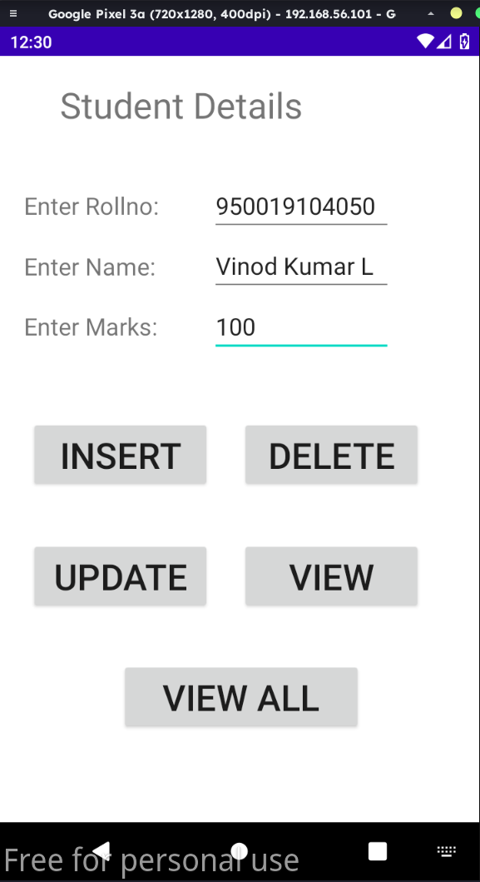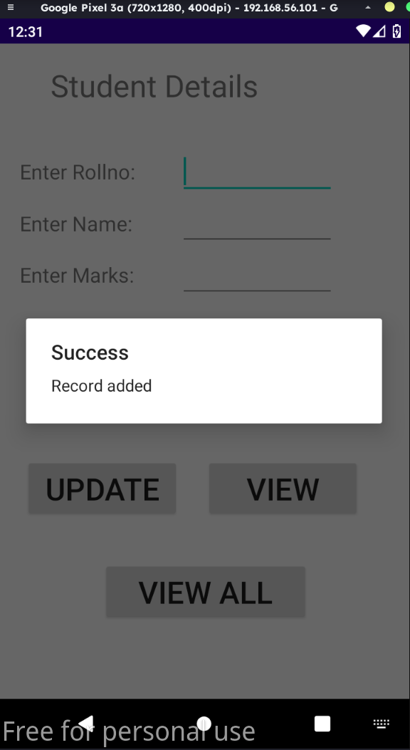

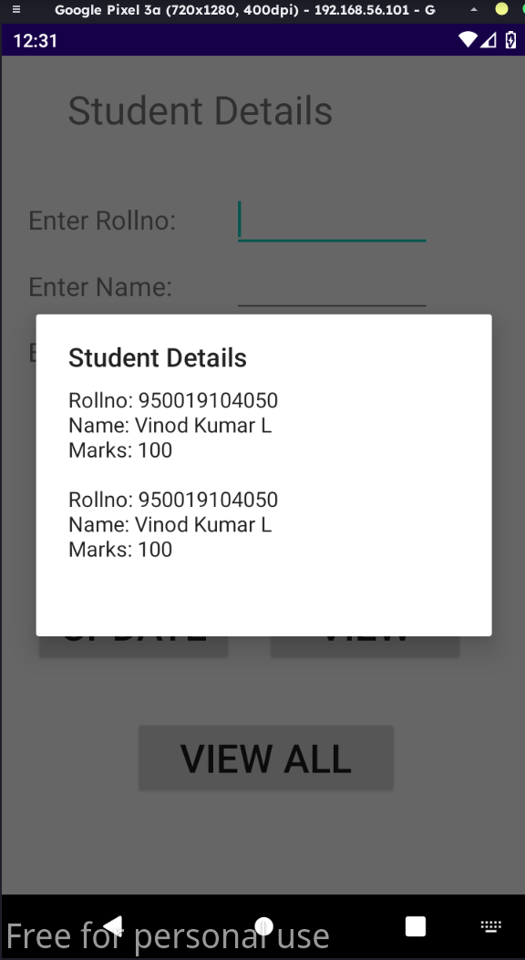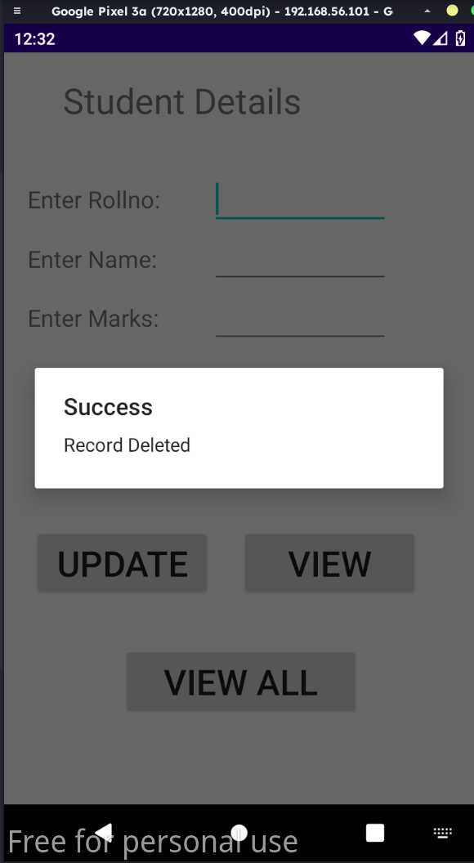

**activity_main.xml:**

<?xml version="1.0" encoding="utf-8"?>

<LinearLayout xmlns:android="http://schemas.android.com/apk/res/android"

xmlns:app="http://schemas.android.com/apk/res-auto"

xmlns:tools="http://schemas.android.com/tools"

android:layout_width="match_parent"

android:layout_height="match_parent"

android:orientation="vertical"

android:gravity="center"

tools:context=".MainActivity">

<Button

android:id="@+id/btnSimpleNotification"

android:layout_width="wrap_content"

android:layout_height="wrap_content"

android:text="Simple Notification" />

<Button

android:id="@+id/btnNotificationIcon"

android:layout_width="wrap_content"

android:layout_height="wrap_content"

android:text="Notification With Icon" />

<Button

android:id="@+id/btnNotificationImage"

android:layout_width="wrap_content"

android:layout_height="wrap_content"

android:text="Notification With Image" />

<Button

android:id="@+id/btnNotificationWithGroupConvo"

android:layout_width="wrap_content"

android:layout_height="wrap_content"

android:text="Notification With Group Conversation" />

<Button

android:id="@+id/btnNotificationSemantic"

android:layout_width="wrap_content"

android:layout_height="wrap_content"

android:text="Notification Semantic Action" />

<TextView android:id="@+id/textView11"

android:layout_width="match_parent"

android:layout_height="wrap_content"

android:gravity="center"

android:text="Name: Vinod Kumar L"

android:textSize="25sp" />

<TextView

android:id="@+id/textView12"

android:layout_width="match_parent"

android:layout_height="wrap_content"

android:gravity="center"

android:text="RegNo: 950019104050"

android:textSize="25sp" />

</LinearLayout>

**MainActivity.java:**

package make.use.of.notification.manager;

import android.app.NotificationChannel;

import android.app.NotificationManager;

import android.app.PendingIntent;

import android.content.Context;

import android.content.Intent;

import android.net.Uri;

import androidx.core.app.NotificationCompat;

import androidx.appcompat.app.AppCompatActivity;

import androidx.core.app.Person;

import androidx.core.graphics.drawable.IconCompat;

import android.os.Build;

import android.os.Bundle;

import android.view.View;

import android.widget.Button;

import android.widget.Toast;

import java.util.Date;

public class MainActivity extends AppCompatActivity implements View.OnClickListener {

NotificationManager notificationManager;

NotificationCompat.Builder builder;

NotificationChannel channel;

CharSequence charSequence = "";

@Override

protected void onCreate(Bundle savedInstanceState) {

super.onCreate(savedInstanceState);

setContentView(R.layout.activity_main);

Button btnSimpleNotification = findViewById(R.id.btnSimpleNotification);

Button btnNotificationIcon = findViewById(R.id.btnNotificationIcon);

Button btnNotificationImage = findViewById(R.id.btnNotificationImage);

Button btnNotificationWithGroupConvo = findViewById(R.id.btnNotificationWithGroupConvo);

Button btnNotificationSemantic = findViewById(R.id.btnNotificationSemantic);

charSequence = btnNotificationIcon.getText();

btnSimpleNotification.setOnClickListener(this);

btnNotificationIcon.setOnClickListener(this);

btnNotificationImage.setOnClickListener(this);

btnNotificationWithGroupConvo.setOnClickListener(this);

btnNotificationSemantic.setOnClickListener(this);

notificationManager = (NotificationManager) getSystemService(Context.NOTIFICATION_SERVICE);

CharSequence name = "My Notification";

String description = "yadda yadda";

int importance = NotificationManager.IMPORTANCE_DEFAULT;

if (Build.VERSION.SDK_INT >= Build.VERSION_CODES.O) {

channel = new NotificationChannel("1", name, importance);

}

if (Build.VERSION.SDK_INT >= Build.VERSION_CODES.O) {

channel.setDescription(description);

}

if (Build.VERSION.SDK_INT >= Build.VERSION_CODES.O) {

builder = new NotificationCompat.Builder(MainActivity.this, channel.getId())

.setSmallIcon(R.mipmap.ic_launcher);

}

if (Build.VERSION.SDK_INT >= Build.VERSION_CODES.O) {

notificationManager.createNotificationChannel(channel);

}

}

@Override

public void onClick(View v) {

switch (v.getId()) {

case R.id.btnSimpleNotification:

simpleNotification();

break;

case R.id.btnNotificationIcon:

notificationWithIcon();

break;

case R.id.btnNotificationImage:

notificationWithImage();

break;

case R.id.btnNotificationWithGroupConvo:

notificationWithGroupConvo();

break;

case R.id.btnNotificationSemantic:

notificationSemantic();

break;

}

}

private void simpleNotification() {

Person jd = new Person.Builder().setName("Vinod Kumar") .setImportant(true) .build();

new NotificationCompat.MessagingStyle(jd)

.addMessage("Check your mail", new Date().getTime(), jd) .setBuilder(builder);

notificationManager.notify(1, builder.build());

}

private void notificationWithIcon() {

Person anupam = new Person.Builder()

.setName("Vinod")

.setIcon(IconCompat.createWithResource(this, R.drawable.ic_launcher_foreground))

.setImportant(true) .build();

new NotificationCompat.MessagingStyle(anupam)

.addMessage("Check your calender!", new Date().getTime(), anupam)

.setBuilder(builder);

notificationManager.notify(2, builder.build());

}

private void notificationWithImage() {

Person bot = new Person.Builder()

.setName("Bot") .setImportant(true)

.setBot(true) .build();

Uri uri = Uri.parse("android.resource://com.journaldev.androidpnotifications/drawable/"+R.drawable.ic_launcher_foreground);

NotificationCompat.MessagingStyle.Message message = new

NotificationCompat.MessagingStyle.Message("Check your calender!", new Date().getTime(), bot);

message.setData("image/*",uri);

new NotificationCompat.MessagingStyle(bot)

.addMessage(message) .setGroupConversation(true).setBuilder(builder);

notificationManager.notify(3, builder.build());

}

private void notificationWithGroupConvo()

{

Person jd = new Person.Builder()

.setName("Vinod Kumar") .build();

Person anupam = new Person.Builder()

.setName("Vinod")

.setIcon(IconCompat.createWithResource(this, R.drawable.ic_launcher_foreground))

.setImportant(true).build();

Person bot = new Person.Builder()

.setName("Bot").setBot(true) .build();

Uri uri = Uri.parse("android.resource://com.journaldev.androidpnotifications/drawable/"+R.drawable.ic_launcher_foreground);

NotificationCompat.MessagingStyle.Message message = new

NotificationCompat.MessagingStyle.Message("", new Date().getTime(), bot);

message.setData("image/*",uri);

new NotificationCompat.MessagingStyle(bot)

.addMessage("Hi. How are you?", new Date().getTime(), anupam)

.addMessage(message)

.addMessage("Does this image look good?", new Date().getTime(), bot)

.addMessage("Looks good!", new Date().getTime(), jd)

.setGroupConversation(true)

.setConversationTitle("Sample Conversation")

.setBuilder(builder);

notificationManager.notify(4, builder.build());

}

private void notificationSemantic()

{

Person jd = new Person.Builder()

.setName("Vinod Kumar")

.build();

Person anupam = new Person.Builder()

.setName("Vinod")

.setIcon(IconCompat.createWithResource(this, R.drawable.ic_launcher_foreground))

.setImportant(true)

.build();

Person bot = new Person.Builder()

.setName("Bot")

.setBot(true)

.build();

Uri uri = Uri.parse("android.resource://com.journaldev.androidpnotifications/drawable/"+R.drawable.ic_launcher_foreground);

Intent intent = new Intent(this, MainActivity.class);

intent.putExtra("hi","Notifications were read");

PendingIntent pendingIntent = PendingIntent.getActivity(this, 0, intent, 0);

NotificationCompat.MessagingStyle.Message message = new

NotificationCompat.MessagingStyle.Message("", new Date().getTime(), bot);

message.setData("image/*",uri);

NotificationCompat.Action replyAction =

new NotificationCompat.Action.Builder(

R.drawable.ic_launcher_foreground, "MARK READ", pendingIntent)

.setSemanticAction(NotificationCompat.Action.SEMANTIC_ACTION_MARK_AS_READ)

.build();

NotificationCompat.Builder separateBuilder = builder;

separateBuilder.addAction(replyAction);

new NotificationCompat.MessagingStyle(bot)

.addMessage("Hi. How are you?", new Date().getTime(), anupam)

.addMessage(message)

.addMessage("Does this image look good?", new Date().getTime(), bot)

.addMessage("Looks good!", new Date().getTime(), jd)

.setGroupConversation(true)

.setConversationTitle("Sample Conversation")

.setBuilder(separateBuilder);

notificationManager.notify(5, separateBuilder.build());

}

@Override

protected void onResume() {

super.onResume();

if(getIntent()!=null && getIntent().getExtras()!=null)

{

String value = getIntent().getStringExtra("hi");

Toast.makeText(getApplicationContext(),value,Toast.LENGTH_LONG).show();

}

}

}

**Output:**

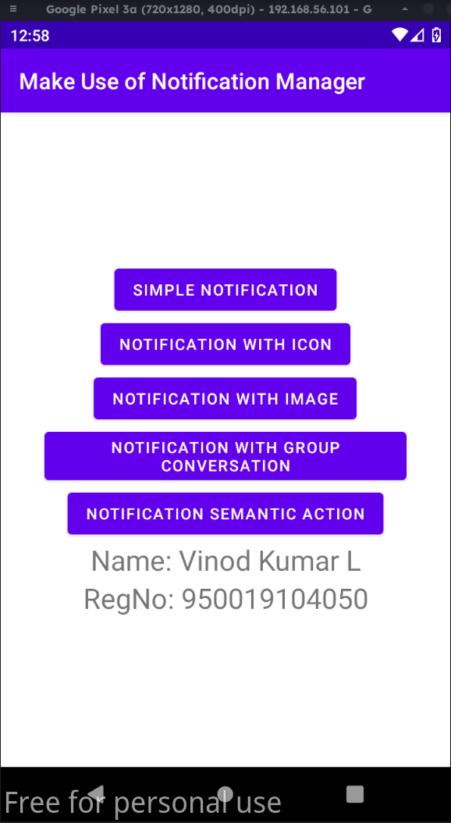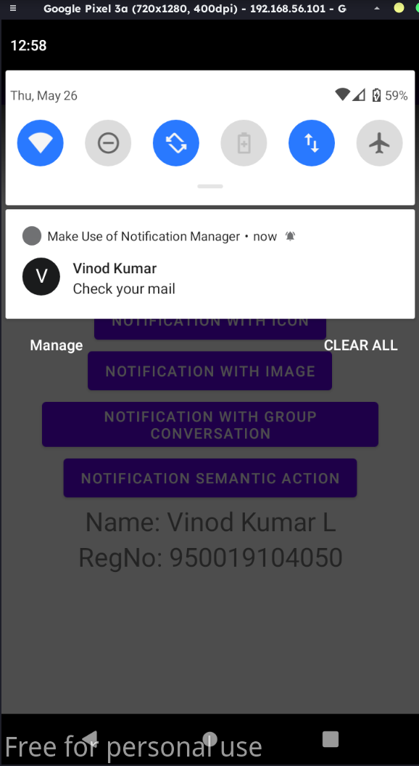

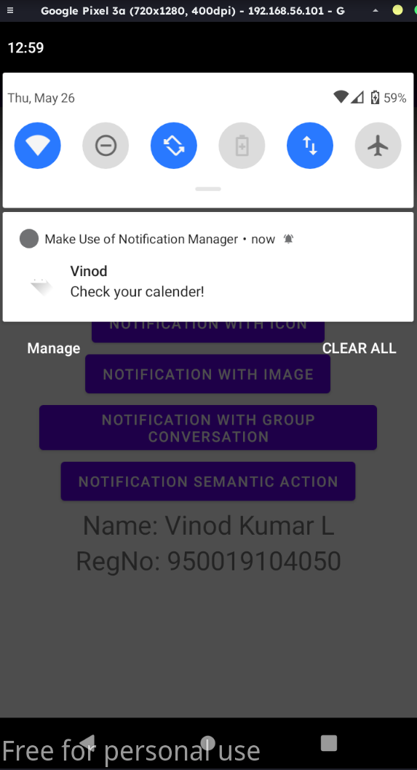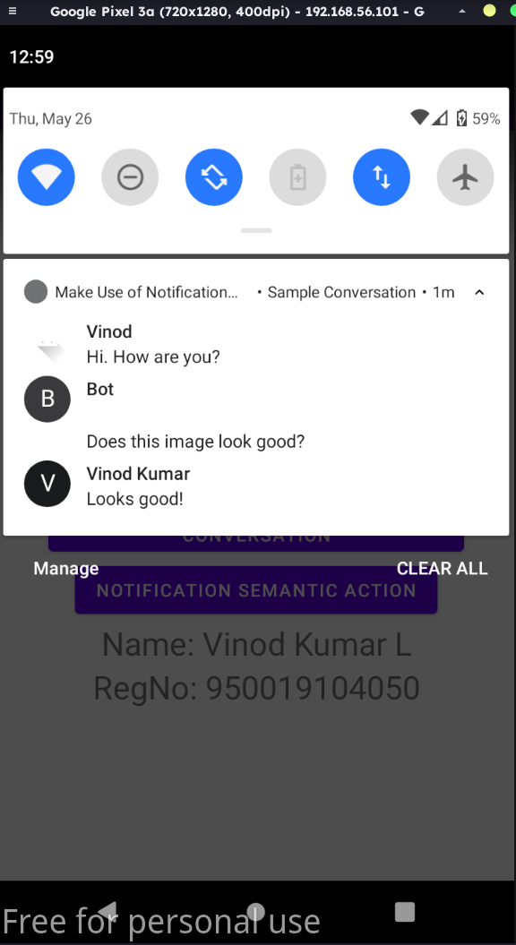

**activity_main.xml:**

<?xml version="1.0" encoding="utf-8"?>

<LinearLayout xmlns:android="http://schemas.android.com/apk/res/android"

android:layout_width="match_parent"

android:layout_height="match_parent"

android:orientation="vertical" >

<ImageView

android:id="@+id/imageView"

android:layout_width="250dp"

android:layout_height="250dp"

android:layout_margin="50dp"

android:layout_gravity="center" />

<Button

android:id="@+id/button"

android:layout_width="wrap_content"

android:layout_height="wrap_content"

android:layout_margin="10dp"

android:layout_gravity="center"

android:text="Load Image 1" />

<Button

android:id="@+id/button2"

android:layout_width="wrap_content"

android:layout_height="wrap_content"

android:layout_margin="10dp"

android:layout_gravity="center"

android:text="Load image 2" />

<TextView android:id="@+id/textView11"

android:layout_width="match_parent"

android:layout_height="wrap_content"

android:gravity="center"

android:text="Name: Vinod Kumar L"

android:textSize="25sp" />

<TextView

android:id="@+id/textView12"

android:layout_width="match_parent"

android:layout_height="wrap_content"

android:gravity="center"

android:text="RegNo: 950019104050"

android:textSize="25sp" />

</LinearLayout>

**MainActivity.java:**

package multi.threading;

import android.os.Bundle;

import android.view.View;

import android.widget.Button;

import android.widget.ImageView;

import androidx.appcompat.app.AppCompatActivity;

public class MainActivity extends AppCompatActivity

{

ImageView img;

Button bt1,bt2;

@Override

protected void onCreate(Bundle savedInstanceState)

{

super.onCreate(savedInstanceState);

setContentView(R.layout.activity_main);

bt1 = (Button)findViewById(R.id.button);

bt2= (Button) findViewById(R.id.button2);

img = (ImageView)findViewById(R.id.imageView);

bt1.setOnClickListener(new View.OnClickListener()

{

@Override

public void onClick(View v)

{

new Thread(new Runnable()

{

@Override

public void run()

{

img.post(new Runnable()

{

@Override

public void run()

{

img.setImageResource(R.drawable.archlogo);

}

});

} }).start();

} });

bt2.setOnClickListener(new View.OnClickListener()

{

@Override

public void onClick(View v)

{

new Thread(new Runnable()

{

@Override

public void run()

{

img.post(new Runnable()

{

@Override

public void run()

{

img.setImageResource(R.drawable.archlogo1);

} });

}

}).start();

} });

}}

**Output:**

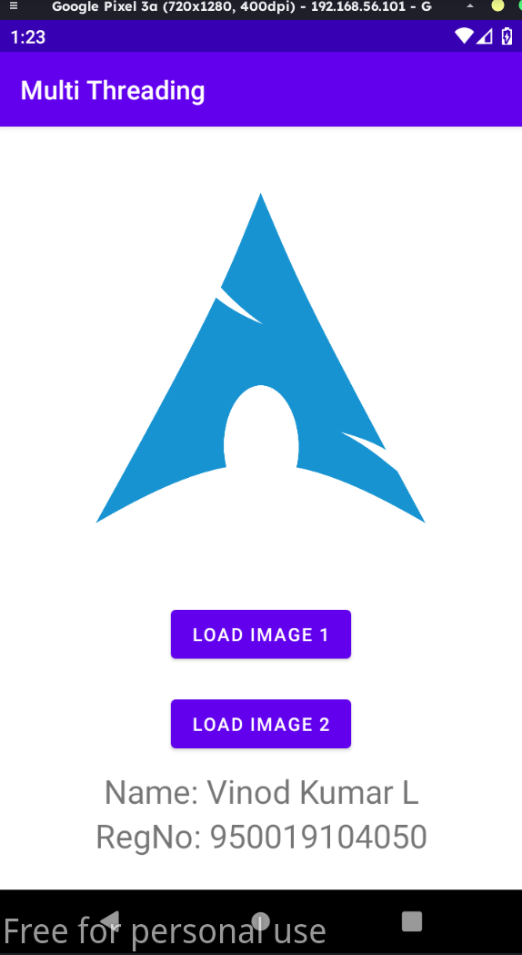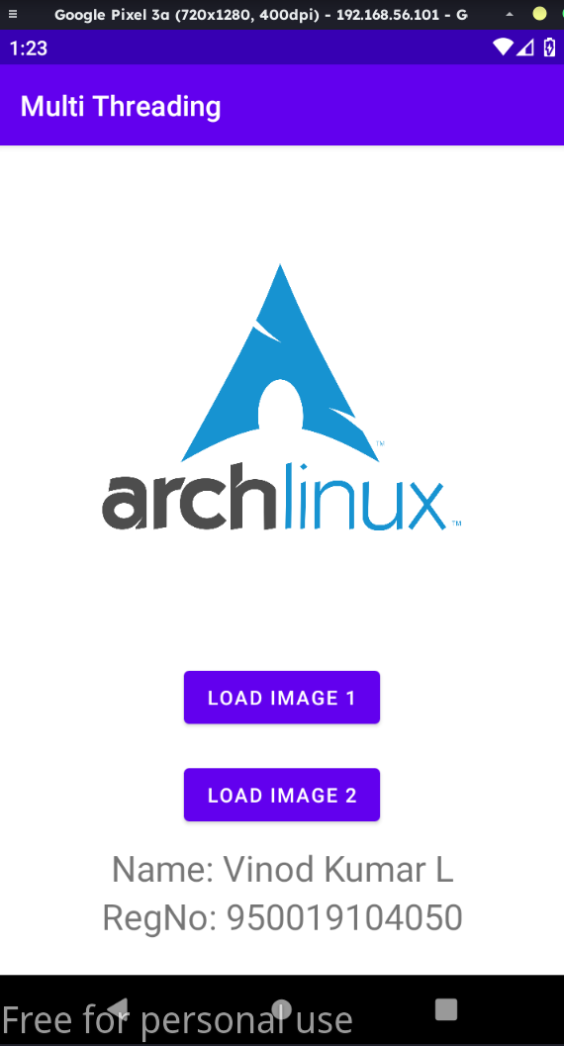

**activity_main.xml:**

<?xml version = "1.0" encoding = "utf-8"?>

<LinearLayout xmlns:android = "http://schemas.android.com/apk/res/android"

android:layout_width = "match_parent"

android:layout_height = "match_parent"

android:orientation = "vertical"

>

<Button

android:id="@+id/button"

android:layout_width="match_parent"

android:layout_height="wrap_content"

android:layout_marginLeft="24dp"

android:layout_marginTop="340dp"

android:layout_marginRight="24dp"

android:backgroundTint="#03FFFFFF"

android:text="getlocation" />

</LinearLayout>

**MainActivity.java**

package gps.location.info;

import android.Manifest;

import android.app.Activity;

import android.content.pm.PackageManager;

import android.os.Bundle;

import android.view.View;

import android.widget.Button;

import android.widget.Toast;

import androidx.core.app.ActivityCompat;

import gps.location.info.GPSTracker;

//import android.support.v4.app.ActivityCompat;

public class MainActivity extends Activity {

Button btnShowLocation;

private static final int REQUEST_CODE_PERMISSION = 2;

String mPermission = Manifest.permission.ACCESS_FINE_LOCATION;

// GPSTracker class

GPSTracker gps;

@Override

public void onCreate(Bundle savedInstanceState) {

super.onCreate(savedInstanceState);

setContentView(R.layout.activity_main);

try {

if (ActivityCompat.checkSelfPermission(this, mPermission)

!= PackageManager.PERMISSION_GRANTED) {

ActivityCompat.requestPermissions(this, new String[]{mPermission},

REQUEST_CODE_PERMISSION);

}

} catch (Exception e) {

e.printStackTrace();

}

btnShowLocation = (Button) findViewById(R.id.button);

// show location button click event

btnShowLocation.setOnClickListener(new View.OnClickListener() {

@Override

public void onClick(View arg0) {

// create class object

gps = new GPSTracker(MainActivity.this);

// check if GPS enabled

if(gps.canGetLocation()){

double latitude = gps.getLatitude();

double longitude = gps.getLongitude();

// \n is for new line

Toast.makeText(getApplicationContext(), "Your Location is - \nLat: "

+ latitude + "\nLong: " + longitude, Toast.LENGTH_LONG).show();

}else{

// can't get location

// GPS or Network is not enabled

// Ask user to enable GPS/network in settings

gps.showSettingsAlert();

}

}

});

}

}

**GPSTracker.java:**

package gps.location.info;

import android.annotation.SuppressLint;

import android.app.AlertDialog;

import android.app.Service;

import android.content.Context;

import android.content.DialogInterface;

import android.content.Intent;

import android.location.Location;

import android.location.LocationListener;

import android.location.LocationManager;

import android.os.Bundle;

import android.os.IBinder;

import android.provider.Settings;

import android.util.Log;

public class GPSTracker extends Service implements LocationListener {

private final Context mContext;

// flag for GPS status

boolean isGPSEnabled = false;

// flag for network status

boolean isNetworkEnabled = false;

// flag for GPS status

boolean canGetLocation = false;

Location location; // location

double latitude; // latitude

double longitude; // longitude

// The minimum distance to change Updates in meters

private static final long MIN_DISTANCE_CHANGE_FOR_UPDATES = 10; // 10 meters

// The minimum time between updates in milliseconds

private static final long MIN_TIME_BW_UPDATES = 1000 * 60 * 1; // 1 minute

// Declaring a Location Manager

protected LocationManager locationManager;

public GPSTracker(Context context) {

this.mContext = context;

getLocation();

}

@SuppressLint("MissingPermission")

public Location getLocation() {

try {

locationManager = (LocationManager) mContext.getSystemService(LOCATION_SERVICE);

// getting GPS status

isGPSEnabled = locationManager.isProviderEnabled(LocationManager.GPS_PROVIDER);

// getting network status

isNetworkEnabled = locationManager

.isProviderEnabled(LocationManager.NETWORK_PROVIDER);

if (!isGPSEnabled && !isNetworkEnabled) {

// no network provider is enabled

} else {

this.canGetLocation = true;

// First get location from Network Provider

if (isNetworkEnabled) {

locationManager.requestLocationUpdates(

LocationManager.NETWORK_PROVIDER,

MIN_TIME_BW_UPDATES,

MIN_DISTANCE_CHANGE_FOR_UPDATES, this);

Log.d("Network", "Network");

if (locationManager != null) {

location = locationManager

.getLastKnownLocation(LocationManager.NETWORK_PROVIDER);

if (location != null) {

latitude = location.getLatitude();

longitude = location.getLongitude();

}

}

}

// if GPS Enabled get lat/long using GPS Services

if (isGPSEnabled) {

if (location == null) {

locationManager.requestLocationUpdates(

LocationManager.GPS_PROVIDER, MIN_TIME_BW_UPDATES,

MIN_DISTANCE_CHANGE_FOR_UPDATES, this);

Log.d("GPS Enabled", "GPS Enabled");

if (locationManager != null) {

location = locationManager.getLastKnownLocation(LocationManager.GPS_PROVIDER);

if (location != null) {

latitude = location.getLatitude();

longitude = location.getLongitude();

}

}

}

}

}

} catch (Exception e) {

e.printStackTrace();

}

return location;

}

/**

* Stop using GPS listener

* Calling this function will stop using GPS in your app

* */

public void stopUsingGPS(){

if(locationManager != null){

locationManager.removeUpdates(GPSTracker.this);

}

}

/**

* Function to get latitude

* */

public double getLatitude(){

if(location != null){

latitude = location.getLatitude();

}

// return latitude

return latitude;

}

/**

* Function to get longitude

* */

public double getLongitude(){

if(location != null){

longitude = location.getLongitude();

}

// return longitude

return longitude;

}

/**

* Function to check GPS/wifi enabled

* @return boolean

* */

public boolean canGetLocation() {

return this.canGetLocation;

}

/**

* Function to show settings alert dialog

* On pressing Settings button will lauch Settings Options

* */

public void showSettingsAlert(){

AlertDialog.Builder alertDialog = new AlertDialog.Builder(mContext);

// Setting Dialog Title

alertDialog.setTitle("GPS is settings");

// Setting Dialog Message

alertDialog.setMessage("GPS is not enabled. Do you want to go to settings menu?");

// On pressing Settings button

alertDialog.setPositiveButton("Settings", new DialogInterface.OnClickListener() {

public void onClick(DialogInterface dialog,int which) {

Intent intent = new Intent(Settings.ACTION_LOCATION_SOURCE_SETTINGS);

mContext.startActivity(intent);

}

});

// on pressing cancel button

alertDialog.setNegativeButton("Cancel", new DialogInterface.OnClickListener() {

public void onClick(DialogInterface dialog, int which) {

dialog.cancel();

}

});

// Showing Alert Message

alertDialog.show();

}

@Override

public void onLocationChanged(Location location) {

}

@Override

public void onProviderDisabled(String provider) {

}

@Override

public void onProviderEnabled(String provider) {

}

@Override

public void onStatusChanged(String provider, int status, Bundle extras) {

}

@Override

public IBinder onBind(Intent arg0) {

return null;

}

}

**AndroidManifest.xml:**

<?xml version="1.0" encoding="utf-8"?>

<manifest xmlns:android="http://schemas.android.com/apk/res/android"

package="gps.location.info">

<uses-permission android:name="android.permission.ACCESS_COARSE_LOCATION" />

<uses-permission android:name="android.permission.ACCESS_FINE_LOCATION" />

<uses-permission android:name = "android.permission.INTERNET" />

<application

android:allowBackup="true"

android:icon="@mipmap/ic_launcher"

android:label="@string/app_name"

android:roundIcon="@mipmap/ic_launcher_round"

android:supportsRtl="true"

android:theme="@style/Theme.GpsLocationInfo">

<activity

android:name=".MainActivity"

android:exported="true">

<intent-filter>

<action android:name="android.intent.action.MAIN" />

<category android:name="android.intent.category.LAUNCHER" />

</intent-filter>

</activity>

</application>

</manifest>